|  |
| --- |
|  |
| Cheesehead hosting  User Manual |
| |  |  |  | | --- | --- | --- | | Author: Group 1 | Date: 10/01/2024 | Version: 1.0 | |

Table of Contents

1 Creating a user account at cheeseheadhosting.nl 2

2 Deploying the website infrastructure 4

3 Uploading the website 7

4 Creating a support ticket 11

# 1 Creating a user account at cheeseheadhosting.nl

* 1. Open your web browser.
  2. A screenshot of a computer

     Description automatically generatedGo to *cheeseheadhosting.nl* see *figure 1.1*

Figure 1.1, Browsing to cheeseheadhosting.nl

* 1. Click on the right top on *register*, see *figure 1.2*

Figure 1.2, Going to the register page.

* 1. Fill in the following fields, see *figure 1.3*.
* Username
* Email
* Password
* Confirm password.
  1. Click on *Create account*, see figure 1.3.

Figure 1.3, Filling in the form and creating an account.

After following those steps, you have successfully created a user account on the CheeseHeadHosting website.

# 2 Deploying the website infrastructure

* 1. Open your web browser.
  2. A screenshot of a computer

     Description automatically generatedGo to *cheeseheadhosting.nl* see *figure 2.1.*

Figure 2.1, Browsing to cheeseheadhosting.nl

* 1. Click on the right top on *login*, see *figure 2.3.*

Figure 1.3, Going to the Login page.

* 1. Fill in the credentials you have created for CheeseHeadHosting, see *figure 2.3*.
  2. Click on *Login*, see *figure 2.3*.

Figure 2.3, Fill in your credentials and logging in.

* 1. Click on *deploy website,* see *figure 2.4.*

Figure 2.4 Going to the Deploy website page.

* 1. Fill in the required fields.
* Preferred region
* Redundancy
* Project name
* Programming language
* Database type
* Email for credentials.

It is important that all the fields are filled in, see *figure 2.5*.

2.8 Click on *Deploy website*, see *figure 2.5*.

Figure 2.5 Filling in the required fields and deploying the infrastructure creation.

After around 5 minutes you will receive an email in your mailbox with all the credentials to access the resources and the DNS name to visit the webpage on.

You have now successfully created the infrastructure to host your website on.

# 3 Uploading the website

**Note**: We weren’t able to implement this functionality within the given time due to errors.

3.1 Go to the email you have received from deploying the infrastructure containing the credentials.

3.2 Open your FTP client of choice, for this use case we will be using FileZilla.

3.3 Click on the *top left* on *File*, see *figure 3.1*.

3.4 Click on *Site Manager*, see *figure 3.1*.

Figure 3.1, Clicking on file and site manager.

3.5 Fill in the received credentials to start the SFTP connection, see *figure 3.2*.

* Host
* Port
* User
* Password

3.6 Click on *connect*, see *figure 3.2*.

Figure 3.2 Filling in credentials and clicking connect.

3.7 Fill in your password when you receive the pop-up after this click on *OK*, see *figure 3.3*.

Figure 3.3 Fill in your password at the pop-up.

3.8 You will now get a pop-up showing that the host key is unknown simply click on *OK*, see *figure 3.4.*

3.9 Optional: You can check the box for Always trust this host, add this key to the cache, so you won’t get this pop-up again.

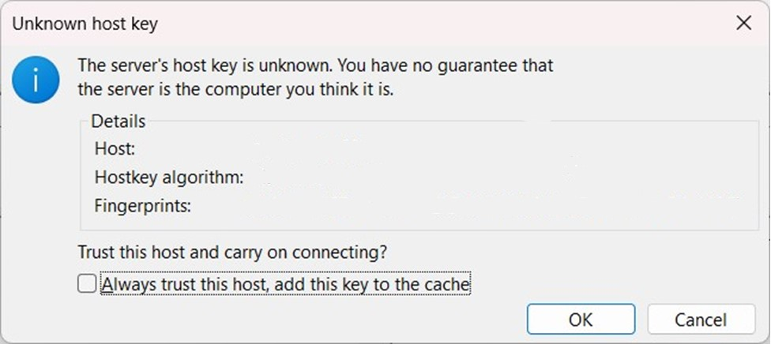

Figure 3.4 Click on OK.

3.9 Locate the website you want to upload and copy it to the SFTP container in the folder upload, see figure 3.5.

**NOTE**: Only upload the content of the website no additional folder where the website is located in.

Figure 3.5 Upload a website to the SFTP container.

3.10 Go to the website you have received from us in the credentials mail. You will see that the website you have uploaded is now hosting on the website.

Figure 3.6 Uploaded website is being hosted.

After following those steps, you have now successfully uploaded your website.

# 4 Creating a support ticket

On all the pages of our website you will see a question mark icon on the bottom left.

4.1 Click on the *question mark Icon* on the bottom left, see *figure 4.1*.

Figure 4.1 Clicking on the question mark.

4.2 In the search bar you can fill in your question. In this case you can search for support and press *enter*, see *figure 4.2*.



Figure 4.2 searching for support.

4.3 Click on *get IT help*, see *figure 4.3*.

Figure 4.3 Clicking on Get IT help.

4.4 Fill in the summary or subject, your question and contact e-mail address, see figure 4.3

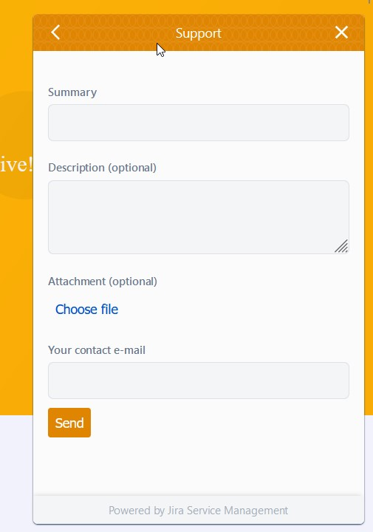

Figure 4.3 Creating support ticket.

After clicking on send you will get a pop-up message saying that your request has been received, *see figure 4.4.*



Figure 4.4 pop-up message after sending a support ticket.

Besides getting a pop-up you will also receive a conformation E-mail mentioning that we have received the request, see *figure 4.5*.

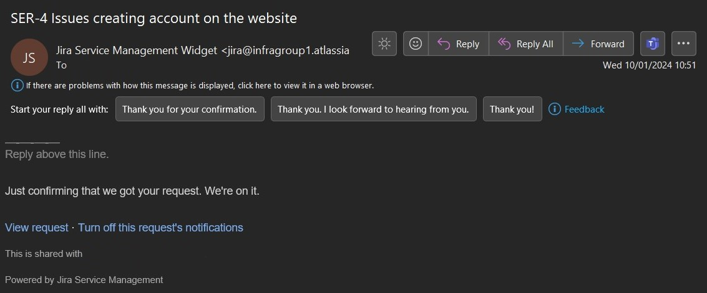

Figure 4.5 Conformation E-mail that you will receive.

After following those steps, you have successfully created a support ticket. Our support team will get back to you as soon as possible.